RESEARCH AND DEVELOPMENT ENTERPRISE “IZUMRUD”


ELECTROCHEMICAL SYNTHESIS UNIT FOR
ACTIVATED DISINFECTING, STERILIZING
AND DETERGENT SOLUTIONS

AQUAECA-40
semi-automatic

Technical description and operation manual.

Saint-Petersburg

2011

- APPLICATION

1.1. AQUAECA-40 unit (version 4-5К), semi-automatic (hereinafter referred to as “unit”) is designed for electrochemical synthesis of activated disinfecting, sterilizing and detergent solutions.
1.2. The unit is normally used in medical and preventive treatment facilities, disinfecting plants, vacation houses, health resorts, catering and public utilities enterprises, schools, kindergartens, swimming pools, water treatment plants, meat and dairy industry enterprises, agriculture, veterinary science, etc. for the preparation of environmentally clean and highly efficient disinfectant, detergent and sterilizing solutions.
1.3 Operating conditions:
- Ambient air temperature from +10 to +30°С;
- Relative air humidity up to 80% at 25°С;
- Tap water temperature: from +10 to +30°С.
- The water used shall meet the potable water requirements in terms of total mineralization and hardness. With the water total hardness over 4 mg-equ/l, water softeners are required to be used.
- It is not allowed to use water with mechanical impurities (e.g. sand, scale particles etc). AQUAECA unit shall be connected to the water pipeline via a filter which removes mechanical impurities.

2. TECHNICAL SPECIFICATIONS

2.1 | Capacity, with AQUAECA Desy (anolyte), l/h | 40
2.2 | AQUAECA Desy (anolyte) quality parameters:
 | - concentration of active chlorine compounds, mg/l | 100-500
 | - рН-value | 7.0-8.0
2.3 | Sodium chloride consumption per 1 liter of final AQUAECA Desy (anolyte), g/l, maximum | 7
2.4 | Concentration of initial NaCl solution, g/l | 200-300
2.5 | The unit maximum power consumption, W | 650
2.6 | AC power supply:
 | - voltage, V | 220±10%
 | - frequency, Hz | 50/60±0,5%
2.7. | Nominal working current (measured with instrument), А | 5-13
2.8. | Voltage at reactor’s electrodes, V | 24
2.9 | The unit warm-up time, min., maximum | 2
2.10 | The unit dimensions, mm | 340х640х160
2.11 | Weight of the unit, kg | 4

- UNIT’S SET

3.1. | AQUAECA-40 unit semi-automatic. | 1
3.2 | Technical description and operation manual. | 1
3.3. | Water supply flexible hose 1/2”, pcs | 1
3.4. | Indicator strips “Desicont” | 1
3.5. | Salt tank 70 liters capacity | 1

4. AQUAECA UNIT SYSTEM

The main part of the unit is an electrochemical reactor, which is a set of hydraulically parallel-series connected electrolytic elements FAS-5. Each of the elements is an independent flow-type electrochemical reactor. The reactor unit is densely placed inside the unit casing. The following elements are also located within the casing: a water jet pump (injector), which is used as a saline solution dispenser, reactor unit, separate pump for cleaning the reactor unit with acid.
The reactor unit is powered from stabilized voltage converter equipped with a controlling amperemeter “A” mounted on the front panel of the unit. The control is made by the switch, which is designed to change operation modes, indicated by light diodes. The switch has 3 positions: “Work”, “Rinse”, “Clean”.
The side (right) panel of the unit includes the controllers:
- “Aquaeca Desy pH level”
- “Salt consumption level” used for controlling the volume of saline solution added to the tap water flowing through the electrochemical reactor
- “Power” switch used for the unit power supply activation and de-activation.

Figure 1. Location of controls and indications.

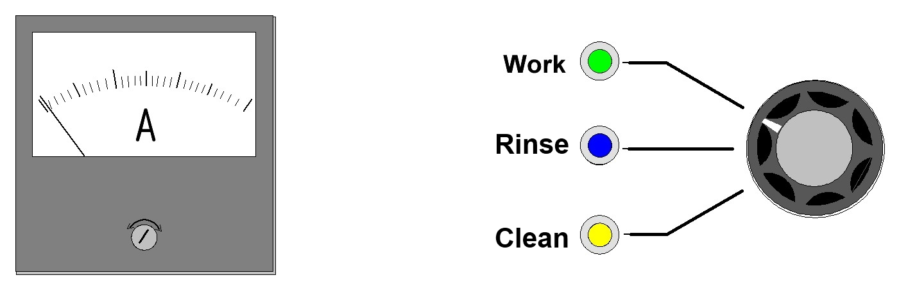

Figure 2. Diagram of AQUAECA unit connection to the main water pipeline.
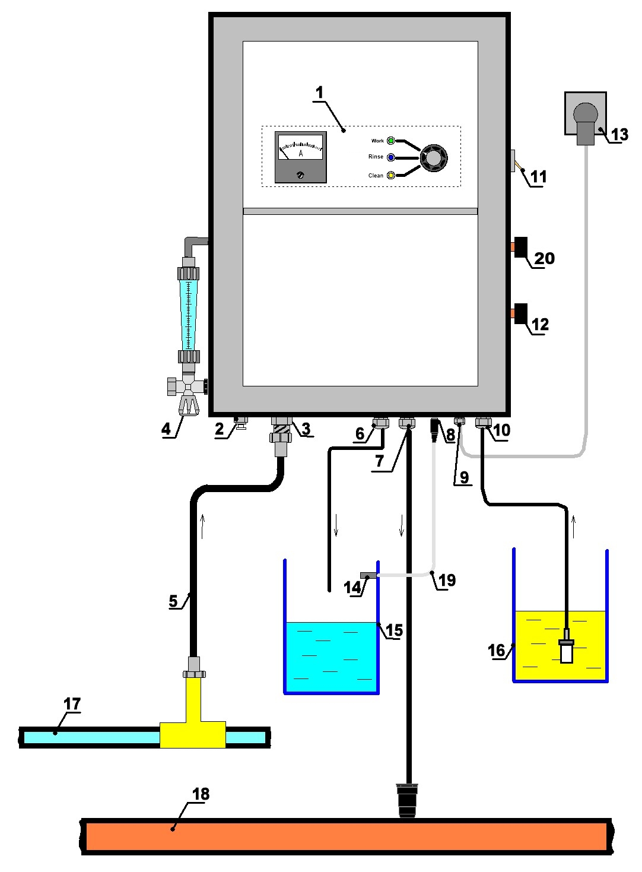

- Control panel.
- HCl acid suction hose fitting for batch cleaning of the unit (“Clean in” label, “Clean” mode)
- Fitting for the unit connection to the water pipeline (“Water in”).
- Flow meter with control valve.
- Flexible water supply hose (1/2”).
- AQUAECA Desy output hose (“Aquaeca Desy out”).
- AQUAECA Limi output hose (“Aquaeca Limi out”).
- Level gauge socket (“Level gauge in”).
- Power cable.
- NaCl input hose (“Salt in”).
- “Power” toggle switch
- Saline solution control valve “Salt consumption level”.
- Power plug.
- Level gauge.
- AQUAECA Desy collection tank.
- Saturated salt solution tank.
- Main water pipeline.
- Main sewage pipeline.
- Level sensor connection cable.
- AQUAECA Desy solution pH level controller

Figure 3 . AQUAECA Desy level gauge installation and connection.
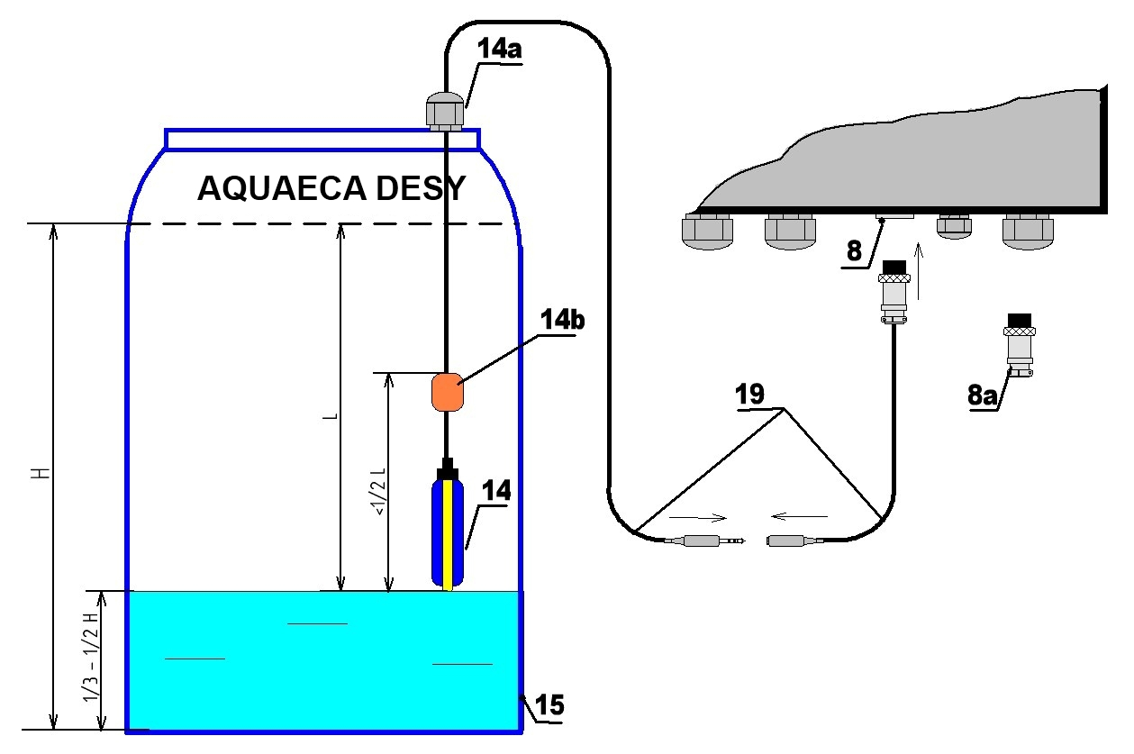

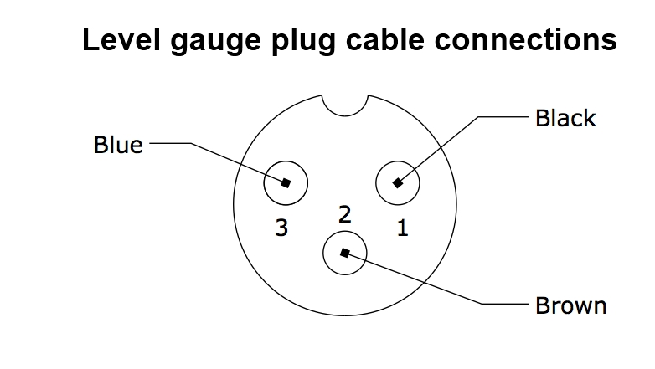

8. Level gauge connector.
8а. Plug for level sensor.
14. Level gauge.
14а. Gasket (not included)
14b. Plumb
15. AQUAECA Desy collection tank.
19. Level gauge connection cable.

5. PREPARATION FOR USE.

5.1. Place the unit indoor with suction-and-exhaust ventilation in the room in immediate proximity to the water pipeline, sewage pipeline and electrical socket.
5.2. Connect the water fitting “Water in” (3) to the water pipeline using flexible hose (5) and water consumption control valve (4) (if needed), or to the household water supply tap using via adapter.

ATTENTION!
AQUAECA unit shall be connected to the water pipeline through the mechanical admixture filter.

5.3. Mount the level gauge (14) on AQUAECA Desy collection tank (15), as shown on
Figure 3. For this purpose:
- Drill 16 mm hole in AQUAECA Desy collection tank (15) close to the expected upper water level;
- Remove the nut and gasket from the gauge (14). Pull the level gauge cable (19) through the hole in the tank; attach the level gauge with nut and gasket on the tank, as shown in Figure 3.
- Connect the gauge to the socket 8.

ATTENTION!
It is allowed to operate the unit without the level gauge. In this case, install a plug (8a) into level gauge socket (8) and turn the switch nearby to the “Blocked” position

5.4. Prepare saturated sodium chloride (NaCl) solution (250-330 g per 1 liter of water).
For this the follow the procedure:
Add pellets (tablets) of sodium chloride into the saturated solution tank (16) by half of it, then, fill the tank completely with water. After10-15 minutes required for dissolving, mix the fluid. Place the saline solution suction hose (16) with a filter at the end under the non-dissolved salt granules. Connect the water hose to the saturated solution tank (if needed) and plug the controller into power supply (if equipped).
If necessary, add water during the unit operation; mix the solution regularly. Control the salt concentration. If the salt pellets (tablets) level falls to 1/3 of the tank volume, add salt pellets (tablets) until the initial level is reached (no less than half of the tank).
Use the sodium chloride of the following grades:
- Salt pellets (tablets) with chloride concentration no less than 98%.
- Table salt.
- Chemically pure salt.
Do not use sodium chloride with iodine and fluorine content.
If salt in pellets (tablets) is not available, you can use regular (powder) sodium chloride salt with no iodine and fluorine content in order to prepare saturated sodium chloride solution (250-330 g per 1 liter of water).

5.4. AQUAECA Desy output hose (6) shall be sunk into collection tank.
5.5. AQUAECA Limi output hose (7) shall be connected either to the sewage system, or to the sink or to a tank for further use as detergent.
5.6. Connect the unit power plug (13) into the power supply socket.

6. OPERATION PROCEDURE

6.1. Fully close the salt consumption valve “Salt consumption level” (12) by smoothly turning it clock-wise until stop.
6.2. Set the switch into “Work” position.
6.3. Turn on the unit by activating “Power” toggle switch (11).
6.4. Open the water flow control valve (4) and adjust the water flow rate to 40 liters per hour, according to the flow meter (if equipped)

6.5. By slowly opening the salt consumption valve “Salt consumption level”, set the current by ampermeter in accordance with the chart given below. The unit warm-up time to the normal stable operating conditions is 2-3 minutes.

THE UNIT PROCESS FLOW CHART

Mode | I, А | Qad, l/h | Qal, l/h | Са.ch.,  mg/l | Са.ch.,  % | pH
1 | 5 | 40 | Up to 5 | 100 | 0.01 | 7.2
2 | 7.5 | 40 | Up to 5 | 300 | 0.03 | 7.2
3 | 13 | 40 | Up to 5 | 500 | 0.05 | 7.2

Recommended current shall not exceed 13 A

LEGEND:

I – current, А;
Qad - volumetric flow rate of AQUAECA Desy, l/h;
Qal – volumetric flow rate of AQUAECA Limi, l/h;
Са.ch. – concentration of active chlorine compounds in AQUAECA Desy, mg/l, %.
*- Qal flow rate either set by the manufacturer in accordance with the required AQUAECA Desy рН-value or is regulated by the user via AQUAECA Desy рН level controller (20) on right side of the unit (if equipped)

ATTENTION! DO NOT SET CURRENT VALUE ABOVE 13 А (by ampermeter).

6.6. After completing all works on the unit, do the following:

- Take out salt solution suction hose “Salt in” (10) from the salt solution tank and placed into the tank with water;
- In 2-3 minutes after current decreases almost to zero, set the switch on the control panel into “Rinse” position, while the toggle switch “Power” (11) should be turned on in the meantime;
- AQUAECA Desy output hose (6) shall be placed into a sink, or a separate waste collection tank;
- Rinse the unit in this mode during no less than 10 minutes;
- After finishing rinsing process, set “Power” toggle switch (11) into OFF position

7. MAINTENANCE.

7.1. Perform maintenance of the unit every 50-60 running hours by cleaning the reactors with 10% hydrochloric acid solution (10% НСl) to remove cathode buildups on the electrodes.
7.2. Clean with 10% hydrochloric acid solution (10% НСl) in the following order (refer to Figure 4.):

- Close “Salt consumption level” valve (12);
- Prepare 1- 1.5 liters of 10% hydrochloric acid solution (10% HCL) in a separate tank;
- Install the tank (20) with 10% acid solution at the level not lower than the unit body;
- Connect HCl suction hose (2) to the unit “Clean in” fitting and place the hose’s end (2) into acid solution tank;
- Place AQUAECA Desy (6) and AQUAECA Limi (7) output hoses into the same tank;
- Set the switch on the control panel (Figure 1) into “Clean” position. “Power” toggle switch shall be switched off;
- Turn on “Power” toggle switch;
- To dissolve cathode build-ups, run the unit at this mode not less than 1 hour.
- After at least one hour replace the hydrochloric acid solution (10% HCL) with fresh water while the unit is running at “Clean” mode. Run for 5-10 minutes.
- After finishing set “Power” toggle switch into OFF position.

7.3. After cleaning the unit with acid, rinse the system with water. For this purpose:
- AQUAECA Desy (6) and AQUAECA Limi (7) output hoses shall be connected to the sewage system, or placed into the sink, or any separate waste collecting tank;
- Set the switch into the “Rinse” position, then set the “Power” toggle switch into the “ON” position;
- Rinse the unit with water during not less than 10 minutes;
- After rinsing, set “Power” toggle switch into OFF position;

Figure 4. Unit connection diagram in the acid washing mode.

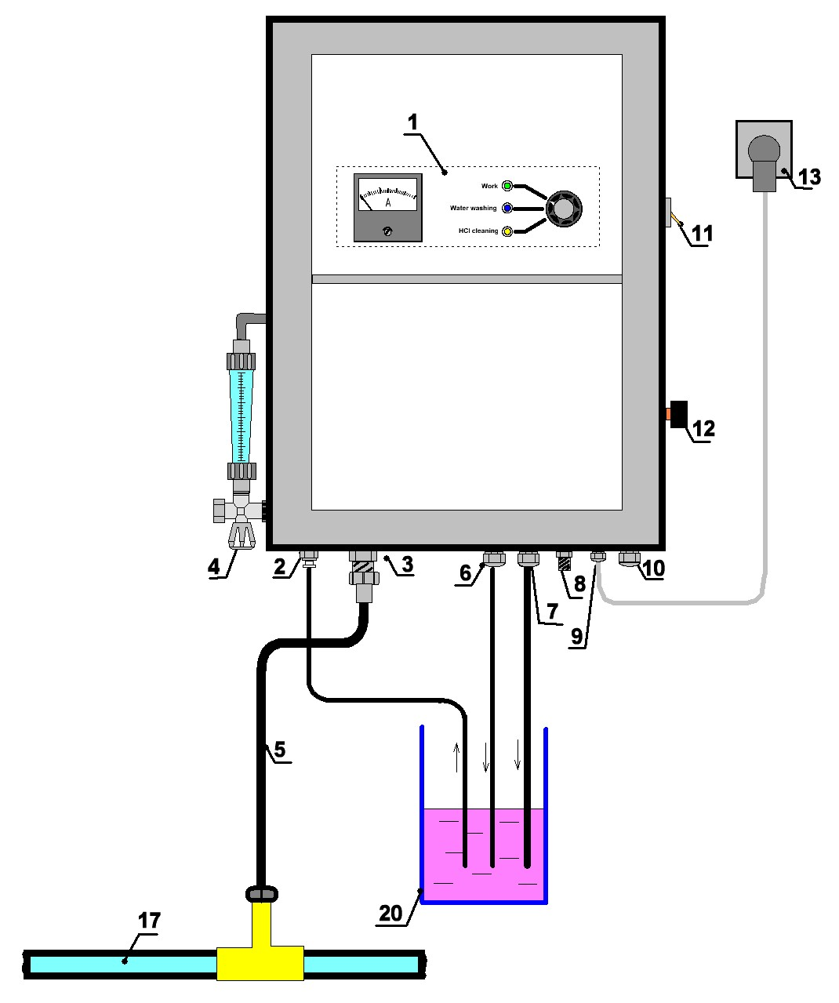

- Control panel.
- HCl acid suction hose fitting for cleaning («Clean in»).
- Fitting of unit connection to the water pipeline (“Water in”).
- Flow meter with control valve.
- Flexible water hose (1/2”).
- AQUAECA Desy output hose “AQUAECA Desy out”
- AQUAECA Limi output hose “AQUAECA limi out”
- Level gauge socket (“Level gauge”).
- Power cable.
- Saline solution (NaCl) suction hose (“Salt in”) with filter (not shown).
- “Power” toggle switch.
- Saline solution flow control valve “Solution control”.
- Power plug.
- Level gauge (not shown).
- AQUAECA Desy collecting tank (not shown).
- Saturated saline solution tank (not shown).
- Main water pipeline.
- Sewage pipe (not shown).
- Level gauge connection cable (not shown).
- Hydrochloric acid solution (10% HCL) tank.

8. SAFETY MEASURES

8.1. Do not dismantle or repair the unit, while it connected to the power supply;
8.2. Do not store or transport the unit with remaining water at the temperature below 0^{о}С;
8.3. Do not use sodium chloride with iodine and fluorine content to prepare saturated salt solution;
8.4. Do not supply water to the unit that has not been preliminary cleaned from mechanical particles and suspensions;
8.5. Take care when performing the unit maintenance and follow to the safety rules for handling of acids and alkali.

9. FAILURES AND TROUBLESHOOTING

Failure | Potential cause | Troubleshooting
Needed power level (amps) cannot be set. | 1. Saline solution input hose filter blocked, or salt build-up in the filter.  2. Cathode build-up accumulation in the reactor unit.  3. Insufficient concentration of saline solution.  4. Injection pump is clogged.  5. Saline solution concentration is lower than required. | 1. Clean the filter as follows:  - place the hose with saline solution filter into the water tank. Hold within 30-60 minutes, then flush the filter.  - rinse the unit with water as per item 6.6 of the manual.  2. Wash the unit with hydrochloric acid solution according to Section 7 of the manual.  3. Ensure that saline solution concentration is sufficient.  4. Rinse the unit with water as per item 6.6 of the manual. If the failure is not eliminated, contact the manufacturer, or warranty service.  5. Prepare saturated salt solution of required concentration (250-330 g/l)
Volumetric water flow rate lower than 40 l/h. | 1. Low pressure in the main water pipeline.  2. Injection pump is clogged. | 1. Provide the required pressure in the main water pipeline.  2. – disconnect the unit from the main water pipeline (remove the water supply hose);  - set the toggle switches in positions as per item 6.6 of the manual;  - open the valve “Salt consumption level”;  - supply water to the unit through “AQUAECA Desy out” fitting in order to wash the injection pump with water back flow.  If the failure is not eliminated, contact the manufacturer, or warranty service.

Failure | Potential cause | Troubleshooting
Indicator “Work” is not lit. Ampermeter pointer is in “0” position. | 1. Voltage converters disabling due to overload.  Reactor current exceeds the allowable limit value.  1.1. Salt solution flow rate is too high.  1.2. Saline solution residue in the reactors after previous operation of the unit due to insufficient rinsing.  2. Power supply unit disabling due to overheating after prolonged operation at elevated temperatures. | 1.1. Fully close “Salt consumption level” valve;  In 1-2 minutes after the indicator “Work” is lit up, set the required working current by slowly rotating “Salt consumption level” valve;  1.2. Rinse the unit with water as per item 6.6 of the manual;  2. turn off the unit using “Power” toggle switch.  In 30-60 minutes, turn on the unit and set the required operating mode, as described in Section 6 of this manual.
Water enters via salt filter into saturated salt solution tank | Injection pump is clogged | - disconnect the unit from the main water pipeline (remove the water supply hose);  - set the toggle switches in positions as per item 6.6 of the manual;  - open the valve “Salt consumption level”;  - supply water to the unit through “AQUAECA Desy out” fitting in order to wash the injection pump with water back flow.
If any other failures occur, please, contact the manufacturer.

10. HANDLING AND STORAGE

10.1. The unit in original manufacturer’s package shall be transported at temperature from 5 to 40^{о}С and maximum relative air humidity 80% at 25^{о}С.
10.2. The unit shall be stored indoors in original manufacturer’s package at temperature from 5 to 40^{о}С in ventilated area and relative air humidity 80% at 25^{о}С.

11. MANUFACTURER’S GUARANTEES

11.1. The manufacturer guarantees the unit fault-free operation, provided the customer complies with handling, storage installation and operation requirements.
11.2. Guaranteed service life is 1 year after the selling date.

Annex 1

AQUAECA Desy QUALITY CONTROL METHODS

1. AQUAECA Desy solution quality is controlled based on the active chlorine concentration in AQUAECA Desy solution solution and рН-value.
2. Determination of the active chlorine concentration in AQUAECA Desy solution.
2.1. Chemicals used:
Potassium iodine, chemically pure, 10% water solution.
Sodium thiosulphate, pentahydrate according to TU 6-09-2540, 0.1 n. solution.
Sulfuric acid according to GOST 4204, 1 N. solution.
Soluble starch according to GOST 10163, 0.5% solution, formulation as per GOST4919.1.
Distilled water according to GOST 6709.
2.2. Preparation for analysis.
2.2.1. Preparation of 10% potassium iodine solution.
10 g of potassium iodine shall be solved in 90 ml of newly prepared cooled distilled water.
2.2.2. Preparation of sulfuric acid solution.
27 ml of concentrated sulfuric acid is carefully added by small portions and continuously mixing into 750 ml of distilled water, then cooled and conditioned to the final volume of 1 l in a measuring flask.
2.3. Analysis.
Put 10ml of AQUAECA Desy solution into a stoppered cone flask 250 ml capacity, add 5 ml of 10% potassium iodine solution, and 50 ml of 1 normal sulfuric acid solution. The flask content is stirred and placed into a dark place for 5 min. Iodine precipitations are titrated with 0.1 normal sodium thiosulphate solution until bright yellow stain appears, then add 1 ml of 0.5% starch solution, and the final solution is titrated until the blue stain disappears.
2.4. Analysis of observations.
Active chlorine mass fraction Х in percentage shall be calculated by the following formula
where У is exact volume of 0.1 natural sodium thiosulphate solution spent for the titration of the analyze AQUAECA Desy solution, cm³;
У₁ - is exact volume of 0.1 natural sodium thiosulphate solution spent for the titration of the test solution, cm³;
0.003546 – chlorine mass corresponding to 1 cm³ of precise 0.1 natural sodium thiosulphate solution, g;
10 – mass of the analyzed sample of AQUAECA (anolyte) solution, g.
The analysis result is the arithmetic mean value of two parallel definitions.
3. AQUAECA Desy solution рН-value is determined using ionometer I-40.1, or “рН-150", or equivalent in accordance with the instrument’s operation manual.

Annex 2
EXPRESS-TESTING PROCEDURE USING “DESICONT” REAGENT STRIPS
Desicont-NA-01 are reagent strips used for express-testing of the concentrations of neutral AQUAECA Desy working solutions, and issued in accordance with TU 9443-002-11764404-98. These are disposable strips and are designed for visual examination of neutral AQUAECA Desy solutions with concentrations of 0.01; 0.02; 0.03; 0.05; 0.08 % by active chlorine content produced on AQUAECA units.
The set includes:
- Reagent test strips on resin substrate (hereinafter – indicator strips);
- Can (case);
The reagent strips are designed to be used by the personnel of medical and preventive treatment facilities, disinfecting and sanitation-and-epidemiological centers as well as other institutions authorized to perform disinfecting operations.
Application:
Fill a gauge glass with at least 30 ml of the tested AQUAECA Desy solution at room temperature. A reagent test strip is taken out from the case and is submerged into the solution with the indication zone down for 5 seconds (counted with a stop watch). Then, the strip is taken out from the solution, the liquid residue is removed from the strip by moving the strip edge on the glass rim. The strip is then put on absorbent paper with the indication zone upwards and is held in this position within 60 seconds. Then, the indication zone color is compared with the color scale of a reference element within no longer than 30 seconds.
Concentration of each working solution is determined three times.

Neutral AQUAECA (anolyte) working solution concentration measurement procedure.
5 s | ~ 1/2 s | 1 min | max 30 s
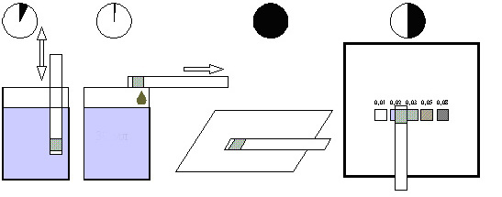

Place the strip into the working solution for 5 s | Remove the solution residue with the strip edge | Put the strip into absorbent paper with the indication zone upwards and hold for 1 minute | Within no longer than 30 seconds determine the solution concentration against the reference element color scale.
Note: Stay within the holding time limits specified for reagent test strips in test solutions as well as on absorbent paper. The reagent test strip color shall be compared against the reference element color scale only in conditions of the working place normal illumination, or under artificial illumination.

Attention:
- Desicont-NA-01 reagent strips are not allowed are be used to determine solution concentrations of other disinfectants;
- Protect the reference element form direct sunlight as well as from impacts of various disinfectants;
- Do not use the solution portions that were used to determine AQUAECA Desy solution concentrations with reagent test strips, for disinfecting purposes;
- Take out from the case only such number of reagent strips, which is required to determine concentrations; always close the case.
Storage:
Reagent test strips shall be stored and handled in the manufacturer’s original package at the temperatures from -15°С to +40°С and relative humidity no higher than 80% at 25°С without subjecting the same to the vapors of chemical compounds.
Annex 3
EXPRESS-TESTING OF DETERMINING ACTIVE CHLORINE CONCENTRATIONS.
In order to save time and chemical agents used for determining active chlorine concentrations, it is allowed to use a simplified express-test procedure.
Procedure 1. Comparison of portion of AQUAECA Desy dyed solution against the color scale with addition to the portion of small amount of potassium iodine:
* fill the test tube by half (10-20 ml) with AQUAECA Desy solution;
* add one spoon of potassium iodine (500 mg) by sight, then stir;
* by comparing the solution color intensity with the corresponding grading on the color scale with the specified active chlorine values, you can determine the approximate active chlorine concentration in the final AQUAECA Desy solution.
Annex 4
DISINFECTING QUALITY CONTROL PROCEDURE

1. Disinfection quality shall be evaluated after disinfection being conducted by way of bacteriological examination of bacterial content of disinfected facilities with the view of identifying Staphylococcus aureus, Pseudomonas aeruginosa and coliform bacteria.
2. Samples are taken using wipe sampling method.
2.1. Surfaces (surface areas) of different units (see item 2.2.) are thoroughly wiped with sterile gauze napkin (napkin size - 5×5 cm) moistened with a sterile neutralizing agent solution (0.5% sodium thiosulfate solution). Then, the napkin is placed into sterile test tube with 10 cm³ of the above mentioned sterile neutralizing agent solution and sterile glass beads, then shaken for 5 min avoiding the plug getting moistened.
2.2. When testing small-size objects (dishes, toys etc), samples are taken from the whole surface of the object. In case of large surface objects (floor, walls, furniture etc), wipe samples are taken from the surface of no less than 100 cm².
2.3. When testing medical purpose products (except for products with ducts and small objects), wipe samples are taken the same way in accordance with the same procedure (see item 2.1.) from the surface of the product’s working part.
The working end of the products with functional ducts is lowered into a sterile test tube with a sterile neutralizing agent solution. Then, the duct is washed with the above solution once or twice using a sterile syringe or pipette.
When taking samples from small size products, the latter are completely submerged into a test tube filled with sterile neutralizing agent solution and then shaken within 5 minutes.
Only 1% of simultaneously treated products of the same trade name (but no less than 3 products) are subject for testing.
3. The wiping fluid (test tubes filled with neutralizing agent solution used for sampling) is used for inoculation by 0.1 ml of vitelline-salt agar or blood agar or Endo agar. The inoculations are held within thermostat at 37^{о}С. The results are recorded after 48 hours.
4. If the bacteria colonies are growing, the resultant microgerms are identified on the specified agars in accordance with the existing methodological documentation.
If there is no growth of bacteria colonies specified in para 1, disinfection is considered ineffective.
Annex 5

USE OF SUPER SPEEDFIT TYPE QUICK CONNECTIONS PRODUCED BY JOHN GUEST.

1. Super Speedfit fitting is comprised of three parts - body, O-ring and collet clamp.
To install and use the fitting, perform the following operations:
- Cut off the required length of tube so that the cutting plane would be normal to the tube longitudinal axis. Remove sharp edges and burrs. Rigid plastic inserts are recommended for soft and thin wall tubes.
- The tube installation and dismantling shall be performed in accordance with the below figure.
Tube connection.
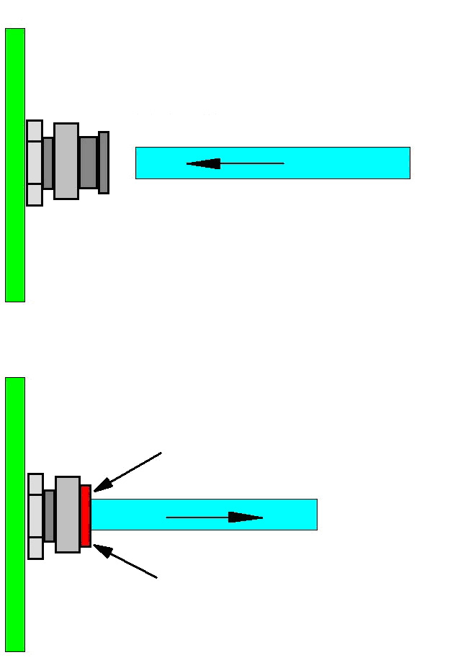
Insert the tube until stop.
Press the coupling.
Tube removal.
Remove the tube.
3. Before dismantling the tube, make sure that the system is de-pressurized. The coupling may be used many times.

Annex 6

RECOMMENDATIONS ON THE UNIT OPERATION AT ELEVATED TEMPERATURES (ABOVE 30°С).

- When operating the unit at elevated temperature and with the working current exceeding 12 А, it is recommended to turn off the unit to cool it down within 20-30 minutes after every 3-4 hours of continuous operation.
- It is recommended to provide additional air income to the cooling system suction holes using an external ventilator.
- Inadvertent shutdown of the unit during continuous operation for more than 3 hours and with the working current over 12 А does not mean a failure. In this case, proceed as follows:
- Turn off the unit with “Power” toggle switch.
- After 30-60 minutes, start the unit and adjust the required operating mode in accordance with Section 6 of this manual.
- AQUAECA Desy solution heating by 15-20°С compared to the inlet water temperature is a normal operation mode and does not imply any additional actions.

